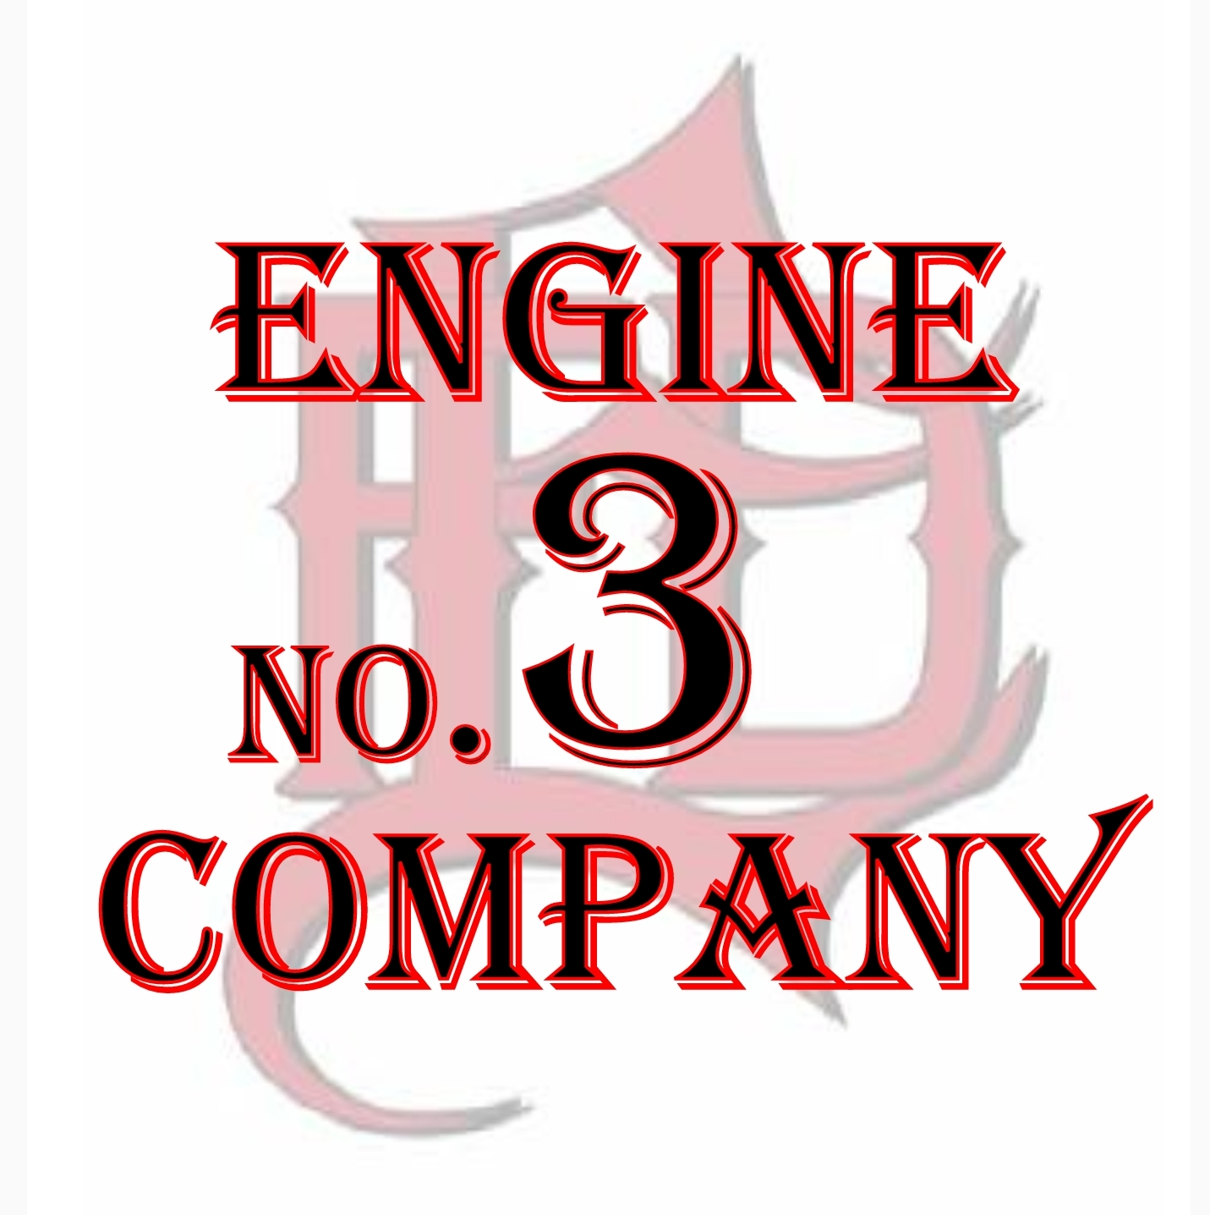
Red Shift

Red Shift
Probationary Firefighter Task Book
Recruit Name
Red 3 Crew Members
Captain Jeremy Sanders 405-702-2134
Driver Justin Mann 405-637-4718
Firefighter Steven Rakett 405-519-2621
Firefighter Cody Sanders 405-639-9595

Red Office Members
Battalion Chief Barry Garrett 405-820-3064
Lieutenant Bill Brown 405-657-8238
Lieutenant Travis Haddock 405-359-0928
Lieutenant Brian Hale 405-314-3205

Introduction:
Welcome to Red 3! We are always excited to have new firefighters join our crew and we look forward to getting to know you and seeing how you can contribute to our team. The culture that we can enjoy at Red 3 is the result of years of hard work and it is something that we are very proud of. The expectations of each of our crew members is much higher than most others. Our goal is to build a tight knit team of motivated professionals and position ourselves for success.
This is not a crew that excepts mediocrity or minimum standards, we’re here every day working to be better than the last. Growth is a constant focus for us. At times it will be uncomfortable and challenging but understand that we are all learning and growing in some way. We are not asking for perfection just hard work. We all have weaknesses and areas that we need to work on so let’s help each other reach their full potential.
We are here to do everything in our power to help you establish a firm foundation to build your career on, but we are also looking to see what you can add to the team. Listen more than you talk but don’t be afraid to ask questions. By teaching you we will be learning a lot ourselves and we will soon be empowering you to move from a student mindset to a leader/teacher mindset. But we will get to all of that in time.
The Red 3 on our helmets is a symbol of our commitment to the team and is earned not given. You now have a seat at our table but to truly be a part of this team you will need work hard and prove to us that you want to be here. We are glad that you have joined our team and stand ready to guide you through your probationary year.
Work hard, always be involved, stay positive, & have fun!
Procedure:
- Day 1
  - Show up on time (0631 is late) excited to start this new journey.
  - Get help making coffee then focus on learning the job.
  - Do not worry about cleaning, cooking, or other “new boy” tasks. Today your #1 responsibility is to learn.
  - At least one of us will be with you most of the day going over the medical kits, rig equipment, PPE, playbook assignments, etc.
  - Any down time can be used going over our playbook and familiarizing yourself with our rig.

- First Month (ish)
  - Focusing a lot on the fundamentals of our job (pulling lines, flowing water, forcing doors, ladders).
  - Working through scenarios to help you become familiar with our playbook.
  - Working on SCBA confidence and comfort level.

- Months 2 & 3
  - Fine tuning and polishing the fundamentals & advancing our skill level.
  - Gaining confidence and competence in your skill to build trust and become independent.
  - Begin working on problem solving and working under stress

- Months 4+
  - Begin stepping into a teaching role informally.
  - Start thinking about what areas you are most interested in.
  - Learn more about those interests and begin to share what you’ve learned.
  - Able to be trusted to complete basic tasks on your own without oversight.

Administrative Ops

Skill | Date | Signed Off
Explain proper procedure for calling in sick.
Explain proper procedure for reporting an injury.
Discuss with crew options & benefits for additional retirement accounts.
Familiarize yourself with what map page numbers we cover first due.

Comments:

PPE Familiarization

Skill | Date | Signed Off
Establish a comfortable gear set up.
Learn what each team member carries in their pockets.
Mask up in 20 seconds or less.
Describe location of critical SCBA parts without having one to look at.
Deploy & hookup the buddy breather, explain the procedure.
Quickly move gear from BP to Engine on structure fire response.
Explain procedure to take if you find a problem while checking out your SCBA .
Learn and verbalize proper radio traffic as well as radio designations for suppression personnel.
Properly operate the 4 Gas Monitor.
Memorize compartment contents in E-3, BP-3, & Tnk-3.
Explain minimum PPE our crew responds with on Accident w/Injury, Smoke In A Structure, Grass Fire, & Automatic Alarm.

Comments:
SCBA Confidence

Skill | Date | Signed Off
Demonstrate wheel breathing, box breathing, hum breathing & skip breathing.
Calmly traverse through varying sized low-profile holes.
Calmly complete a wire box evolution.
Complete maze trailer evolution.
Complete an on air workout until cylinder is empty.
Explain procedure for finding yourself in a Mayday situation.

Comments:
Forcible Entry Familiarization & Operation

Skill | Date | Signed Off
Describe the parts of the haligan, axe/maul, & hook.
Explain & demonstrate proper haligan tuning.
Explain the difference in the MaxxRexx and Probar. Which is your favorite?
Competently execute a single person outward swing force.
Competently execute a single person inward swing force.
Competently execute a 2 person outward swing force. (Striking & Haligan Positions).
Competently execute a 2 person inward swing force utilizing a bevel to the jamb technique. (Striking & Haligan Positions)
Competently execute a 2 person inward swing force utilizing a bevel to the door technique. (Striking & Haligan Positions)
Demonstrate the use of a hook to gain leverage on an outward swing force.
Demonstrate the use of a shove knife.
Competently force a door with zero visibility (1 and 2 person).
Competently force a door with a haligan & a wedge only.
Force outward & inward door and mask up in less than 60 seconds.
Competently force a door with a haligan & hook only.
Develop the habit of looking for “Lift, Life, & Layout” after every force.

Comments:
Nozzle & Hose Familiarization

Skill | Date | Signed Off
Proficient at building clean 1 ¾” bundles .
Proficient at building clean 2 ½” bundles .
Know & Explain how front bumper lines are loaded & Deployed.
Know & Explain how the 2 crosslays are loaded & Deployed.
Know & Explain How the 2 ½” Hose is loaded & deployed.
Proficient deploying the red line and reloading it.
Explain the steps to go through if nozzle flow is not desirable.
Explain the process of “resetting a fire”.
Understand and explain the difference in Big 10 & Combat Sniper hose.
Explain the GPM of all of our nozzles on E3 and how long they can flow off of our booster tank.
Explain the process of estimating the stretch.
Explain and Demonstrate hooking to a standpipe.
Explain the process of performing a terrace drop.
Explain what our “Plan A Attack” is for Covell Village Apart., Reed’s Landing, The Greens, & Touchmark.
Explain main concerns and safety points to consider while attacking car & dumpster fires.

Comments:
Nozzle & Hose Operation

Skill | Date | Signed Off
Competency in deploying preconnects in various situations (Parked cars, obstacles).
Know & explain the 3 different lays for deploying bundles & what situations to use each.
Competency in flowing 1 ¾” while in the clamp, hip grip, & lock off.
Competency in flowing 1 ¾” while moving in the hip grip & lock off (including making corners).
Know & explain the technique of pushing down a hall.
Demonstrate the role of the backup firefighter competently.
Understand how differently a properly pumped, over pumped, & under pumped line feels. (1 ¾” & 2 ½”).
Pull a line to the door, mask up, and slow water in less than 60 seconds.
Demonstrate a 2 ½” knockdown then extending with 1 ¾” bundle.
As the nozzle ff effectively communicate to officer & backup ff.
Demonstrate how to horizontally ventilate with a smooth bore nozzle.
Competency in deploying the Blitzfire Nozzle.
Demonstrate competency & ability to use and maneuver 50’ of charged 2 ½”.
Demonstrate competency flowing and moving up stairs.
Demonstrate competency flowing and moving down stairs.
Competency in catching a hydrant .
Learn and understand the significance of fully “tapping” a hydrant.
Properly use and refill the water can.
Familiarize yourself with safely operating the pump on E-3.

Comments:

Playbook Familiarizaion & Operation
Skill | Date | Signed Off
Accurately describe roles of irons ff, nozzle ff, & 5th ff on a basic structure fire.
Accurately describe roles of irons ff, nozzle ff, & 5th ff on a basic structure fire requiring a line extension.
Accurately describe roles of irons ff, nozzle ff, & 5th ff on a standpipe building.
Accurately describe roles of irons ff, nozzle ff, & 5th ff on a 1st floor VES.
Accurately describe roles of irons ff, nozzle ff, & 5th ff on a 2nd floor VES.
Accurately describe roles of irons ff, nozzle ff, & 5th ff on a smoke in a structure.
Accurately describe roles of irons ff, nozzle ff, & 5th ff on an automatic alarm.
Accurately describe roles of irons ff, nozzle ff, & 5th ff on a RIT deployment.
Accurately describe roles of irons ff, nozzle ff, & 5th ff on a vehicle/dumpster fire.
Competently execute the roles of irons ff, nozzle ff, & 5th ff on a basic structure fire.
Competently execute the roles of irons ff, nozzle ff, & 5th ff on a basic structure fire requiring a line extension.
Competently execute the roles of irons ff, nozzle ff, & 5th ff on a standpipe building.
Competently execute the roles of irons ff, nozzle ff, & 5th ff on a 1st floor VES.
Competently execute the roles of irons ff, nozzle ff, & 5th ff on a 2nd floor VES.
Competently execute the roles of irons ff, nozzle ff, & 5th ff on a smoke in a structure.
Competently execute the roles of irons ff, nozzle ff, & 5th ff on an automatic alarm.
Competently execute the roles of irons ff, nozzle ff, & 5th ff on a RIT deployment.
Competently execute the roles of irons ff, nozzle ff, & 5th ff on a vehicle/dumpster fire.

Comments:

Brush Pumper Familiarization & Grass Fire Ops
Skill | Date | Signed Off
Explain the legal responsibilities of responding code 3.
Familiarize yourself with operating the pump
Able to problem solve pump issues and handle basic issues.
Safely and effectively operate the BP offroad.
Safely and effectively operate the winch.
Describe safety hazards and areas of concern while fighting grass fires.
Explain the specs of BP3 (tank size, hose options available, nozzle specs).
Demonstrate safe operation of the chainsaw.
Demonstrate competency with tablet (rig checks, tickets, in call usage).
Demonstrate basic knowledge of equipment on Tanker 3.
Demonstrate the ability to fill the Brush Pumper tank.

Comments:
RIT, Search, & VES

Skill | Date | Signed Off
Demonstrate competency in search technique.
Describe or demonstrate procedure for clearing beds, bunk beds, & cribs.
Explain parts of the RIT bag.
Demonstrate proper usage of high pressure & low-pressure lines.
Demonstrate competency in VES procedure.
Explain options for victim or firefighter removal.
Demonstrate competently the Denver drill.
Demonstrate a proper window entry & exit.
Demonstrate competency while searching “beyond the door”. Must communicate well.
Demonstrate competency in the procedure of finding a downed firefighter.
Demonstrate and explain the most effective way for taking a window?
Demonstrate competency while performing an oriented primary search independently.
Explain how to size up a house from the exterior for floor layout.

Comments:
Ladder Familiarization & Operation

Skill | Date | Signed Off
Explain what ladders are carried on what EFD rigs.
Describe the capabilities and limitations of the ladders E3 carries.
Demonstrate competency deploying a 24’ extension ladder on your own. (High & Low Shoulder)
Demonstrate competency bringing both the 24’ extension & 14’ to the scene.
Explain what thought process we need to have when deploying ladders for various purposes.
Demonstrate competency while matching the pitch of various roofs. Knowing when it’s “too steep”.

Comments:
Medical Familiarization

Skill | Date | Signed Off
Explain and demonstrate pit crew CPR positions.
Competently assist in IV & fluid set up.
Competently set up 12 lead cables.
Independently fill out run reports.
Familiarize yourself with the medical bags so you can check them out thoroughly by yourself.
Paramedics become familiar with the process of signing drugs in and out.
Become comfortable taking the lead on medical calls.

Comments:

Extrication Familiarization & Operation

Skill | Date | Signed Off
Will add soon.

Comments:

Teaching, Leading, & Ownership

Skill | Date | Signed Off
Study something that interests you in the fire service and teach us what you learned.
Reload hose loads that look like crap.
Always be involved in what is going on.
Come up with a quick drill for the crew several times.
Teach another recruit classmate our system when they travel to our station.
Consistently engaged in training activities.
Make training suggestions when nothing is planned.
Come up with a project to build crew pride.

Comments:
Verification Of Completed
Task Book For Recognition Of

Recruit Name

Becoming A:

Competent Firefighter

FINAL EVALUATOR’S VERIFICATION

I verify that all tasks have been performed
and are complete with signatures.

SUPERVISOR’S SIGNATURE AND DATE

Jeremy Sanders – Captain Red 3
SUPERVISOR’S PRINTED NAME, TITLE, SHIFT, & STATION
Crew’s Charge Going Forward
We verify that all requirements for completing this task book have been met and an important step has been made progressing to a competent firefighter. However, this is only the first step of your young career. We challenge you to continue this path of growth and never lose the drive to get a little better each day.

SIGNATURES OF CREW MEMBERS

